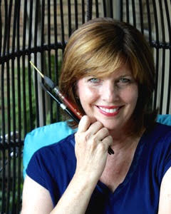

Meet Laura: She’s a native Texan who’s lived in Nevada, Oregon, New Orleans and Nashville. Her recent move to Dallas brought her closer to her roots and has afforded her the opportunity to put aside her career in the non-profit world and pursue a long held dream of creating art full-time.
Art must be in her blood. Her great-grandmother painted flowers and landscapes, her mother painted and drew house plans, and as a child Laura loved art more than any other subject in school! Seeing that passion early on her parents started her in oil painting lessons. Since then she has taken a workshop here and there, but is mostly self-taught. She’s used tole painting, extensive stenciling, oils and acrylics & watercolor as means to create still life studies, landscapes, high-end faux finishes, custom furniture and murals. Currently she's finding ways to create and express in oils, acrylics, and watercolor. Laura creates in her home studio in North Dallas, enjoys plein air trips to various locations and, belongs to local art associations. Laura feels fortunate to love her work! She can often be found with a paint brush or camera in hand while on “vacation”...she just loves to capture the beauty in everyday life! She feels “Every detail, every layer of color, every scene can bring back memories of special moments in our lives. We live on an amazing planet. It’s one of God’s ways of reminding me how much He loves us.”
Her hope is that the viewer will pause to connect and enjoy the beauty of a single flower or bird, the majesty of the Rockies or gorges of The Grand Canyon as she depicts in layers of color, line and visual texture the places that have captured her heart.

