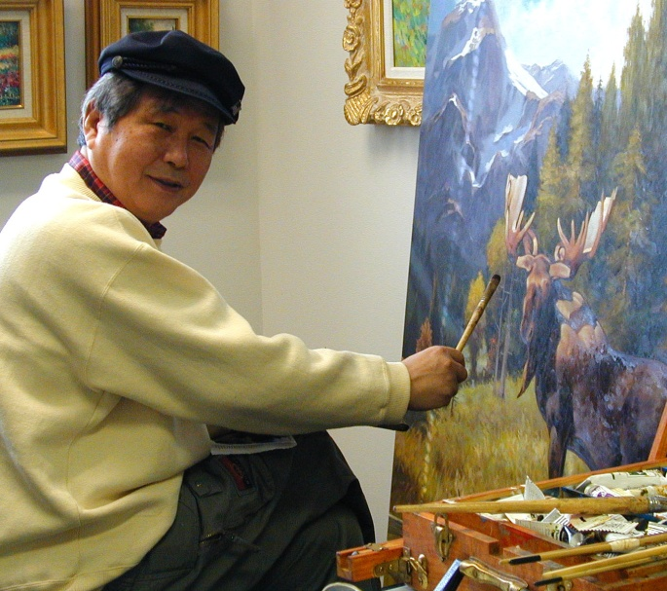

J.C. Seo

J.C. Seo was born December 17,1940.

Dynamic yet contemplative, exacting yet inexhaustibly versatile, J.C. Seo is a complex artist with a rare gift and a spectacular eye. Respected internationally for their mastery of romantic realism, his works are included in fine art collections and galleries throughout the United States and Canada, as well as in the National Museum in his native Korea. His works have been commissioned by General Ray Davis for a depiction of General Douglas Mc Arthur leading troops during the Korean War, and The Holy Innocents High School in Atlanta, Georgia for the Alaskan Brown Bear that represents the school’s authority and foundation. General Ray Davis wrote “Mr. Seo’s great talent and artistic vision are vividly portrayed in his paintings”.

Influenced by 19th century masters like Anders Zorn, Julien BastienLepage and John Singer Sargent, he prefers to work on a warm palette, balancing passages of rich color with delicate grays. Through subtle color harmonies and lighting, J.C. Seo seeks to create a palpable sense of mood in each painting. His methods of application are steeped in tradition but at the same time quite contemporary. His paintings include Botanical Studies and classical close up paintings of local flowers, countryside, harbors, and wild life studies.

Today, Mr. Seo’s network of galleries, dealers, and publishing interests continue to grow worldwide. The evolution of the artist’s success has been born of hard work, discipline, and an unending passion to paint.

The reward for his past efforts and resulting success have allowed J.C. Seo to focus his energy solely on creating new works of art. Seo has been awarded numerous distinctions and his paintings are found in many corporate and private collections around the world.

J.C. Seo is a member of the Korea Fine Art Association, New Fine Art Association, American Art Society, Chung Jo Art Group, International Artist League, Nauri Art Group, Contemporary Korean Artists Group, New Jersey, and Korean American Contemporary Artist, New York.

Exhibitions:

- Chung in Jo Art Group, Duk Won Art Gallery
- International Artists League Annual Group Exhibition, Sejong Cultural Center
- Nauri Art Group, Dong Bang Art Gallery
- Diorama “The Nation’s Ordeal”, exhibited permanently in Korea History Memorial
- Korean Artists Invitational Exhibition, Art Gallery, Atlanta
- Invitational Exhibition, Art Ambassador Art Center, San Diego, CA
- Korean War Veteran Memorial Center, Washington, D.C.
- Portrait Exhibition, Osaka Gallery, Japan
- Special Selection in Seoul Council of Artists
- Gold Award in Seoul Council of Artists
- Grand Prix in Chang, Chun International Art Festival Exhibition China
- Grand Prix in Beijing, Tianchi International Art Exchange Exhibition China
- Auspicious Bird exhibition of Contemporary Korean Artists, Jersey City, New Jersey
- 100 Contemporary Artists Exhibition, Flushing Mall Art Gallery, New York
- Art Expo New York

