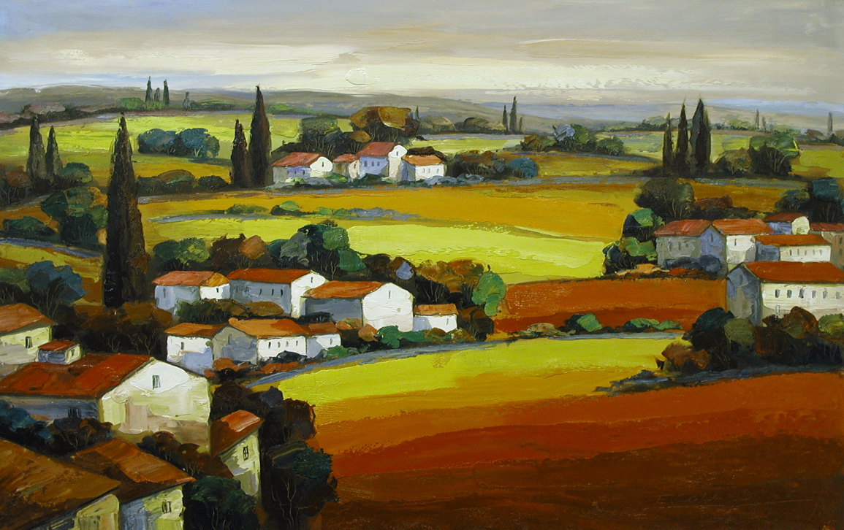

E. COLLINS

Born in 1967 to a family of artists. Collins began to express herself
with a paintbrush at an early age. Her enthusiasm for art continued
and became her life. She graduated from the Fine Art Department of
the Anhui Provence Education Institute, and then completed Graduate School of oil painting in the Guangzhou Fine Arts Institute. Collins and her husband enjoy travels through the countryside that inspire the love of painting that they both share.

Through time and travel her work has evolved, yet it has retained her favorite themes of distant villages, trees, and winding paths, all elements to express her love of shape and color. Colorful and spirited, Collins paints with bold, richly textured movement that combines the classic beautifully formed rolling hillside with a palette knife full of contemporary colors, and spontaneous movement.

Her work is regularly exhibited in galleries and participates in local and International exhibitions. In addition, her work is included in many private and corporate collections throughout the world. Collins was selected to complete a painting symbolizing the Battle of Mountain Road, which is currently displayed in the Chinese People Sino-Japanese War Memorial.

EXHIBITIONS

2005 – Shaghai Spring Artistic Exhibition
Beijing International Art Exhibition
International Home Furnishings Market

